This is the Article Template for Journal of Surgery and Surgical Specialities (Titles should be presented in title case; All botanical names and non-English words should be in italics- both in title and in full text)

Amina Mukhtar Dirir¹, Abdul Jaleel Cheruth² and Taoufik Saleh Ksiksi^{3*}
¹Biology Department, UAE University, Abu Dhabi, UAE (Please provide corresponding author Email ID and indicate with an asterix mark only if there are multiple authors. For single author, there is no need to give the asterix)
²Department of Arid Land Agriculture, College of Food and Agriculture, UAE University, Abu Dhabi, UAE
³Biology Department, College of Science, UAE University, Abu Dhabi, UAE; tksiksi@uaeu.ac.ae (In case of different affiliation for different authors)

Abstract (The abstract introduces the article and should not exceed 300 words, for research articles abstract should be structured)
Abstracts should not exceed more than 300 words and should not contain literature references. The symbols, abbreviations, units and nomenclature used in the text should be in conformity with the recommendations of IUPAC.
Major Findings or Key Findings should be mentioned in not more than 2 to 3 lines.
Keywords: Calotropis Procera, Ethnomedicine, Pharmacology, Phytochemistry, Tribulus Terrestris (3 to 6 Relevant Keywords should be given in alphabetical order with title case and separated by comma)

1. Introduction (Bold and Title case)

- Materials and Methods
2.1 First Level Heading
For a better understanding of the content in the article, we encourage authors to number the article headings in Arabic style format. Headings should follow title case, meaning that all words except for prepositions, articles, and conjunctions should be capitalized. All botanical names should be in italics. In-text Citations are cited as follows:
Single reference: denote it as ¹ (superscript 1)
Two or more references: denote it as ^{1,2}

Example
Single Reference

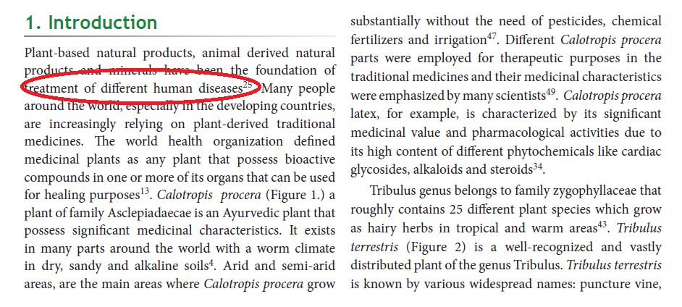
Example For Two or more references
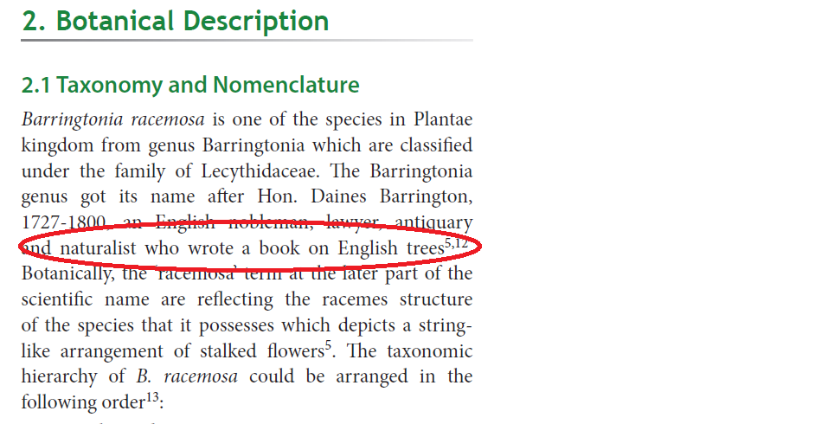
Whenever cited references in range then it will be as follows:
Ex: Intestinal protozoan infections continue to remain a global public health challenge, particularly in developing countries³⁻⁶.
Abbreviations
All abbreviations should be defined on first mention in the text along with the abbreviation in parenthesis. E.g. Magnetic Resonance Imaging (MRI).
If too many abbreviations are there in full text then mention all those together in alphabetical order after keywords and use heading as "Abbreviations"
Units and Symbols
Symbols should be used while referring to alpha, beta, mu, etc (Ex: α, β, µ, etc). All units to follow the International System of Units (SI units).
Equations
Equations and formula should be readable, preferably written using equation editing softwares (E.g. MathType). Alternatively, authors have to provide the fonts used for creating the equations/formulae. Number the equations consecutively with equation numbers in parentheses flush with the right margin, as in (1)
Spreadability (S) = ML/T Eq.-1
Botanical/Zoological/ Names
Example : Calotropis procera

  - Second Level Heading

Sub headings are written in Title Case
Eg:

    - Sub Sub Heading

Sub sub headings are written in Title Case and are italicized.
Eg:
- Results and Discussion
- Conclusion
- Acknowledgments
People who contributed to the work but do not fit the criteria for authors should be listed in the Acknowledgments, along with their contributions. Authors are requested to ensure that anyone named in the Acknowledgment agrees to being so named.

- Funding/Conflicts of interests if any

7. Please mention what each author has contributed to the Manuscript.
Eg: Conceptualization, M.L.G. and M.K.; methodology, M.L.G. and M.K.; software, M.L.G. and M.K.; validation, M.L.G. and M.K.; formal analysis, M.L.G. and M.K.; investigation, M.L.G. and M.K.; resources, M.L.G. and M.K.; data curation, M.L.G. and M.K.; writing—original draft preparation, M.L.G. and M.K.; writing—review and editing, M.L.G. and M.K.; visualization, M.L.G. and M.K.; supervision, M.L.G. and M.K. All authors have read and agreed to the published version of the manuscript.
- References
- Only published or accepted manuscripts should be included in the reference list. Meetings, abstracts, conference talks, or papers that have been submitted but not yet accepted should not be cited.
- In text citations: References cited in text should conform to the Vancouver style. Please refer the Vancouver Style of Referencing. Always follow ascending order of citation in full text.
- Reference List: This should only contain references to those works which you have cited in your text. It should appear at the end of your text. It should be arranged numerically by citation number.

Tables and Figures (Cite the figure and table numbers in full text of the article)

Tables: General guidelines
- Tables should be numbered consecutively in accordance with their appearance in the text and should be cited in full text.
- All tables should have a concise title and written as Table 1 with a period (.).
E.g. Table 1. Stimulation settings.
Footnotes can be used to explain abbreviations. Tables extending beyond 1 page should be avoided.
Eg:
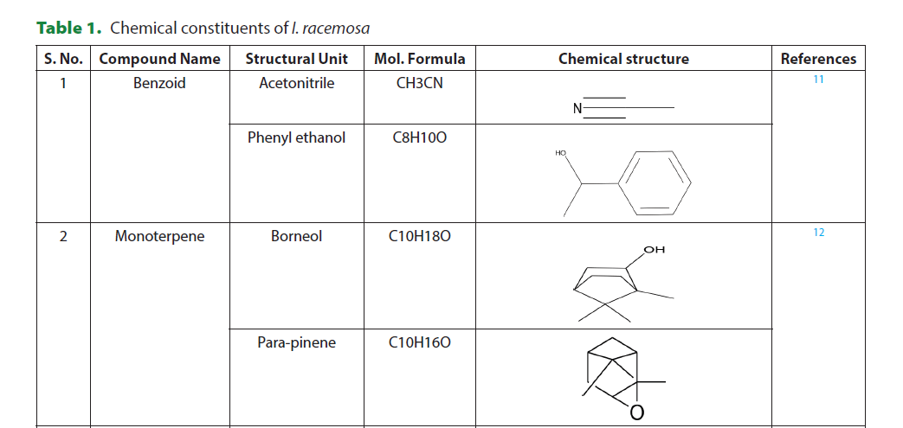

Figures: General Guidelines
- Figures Format & Resolution: Authors are requested to supply high-resolution versions of the figures in TIFF, JPEG or EPS format. We require figures to be created at a minimum resolution:
Black & White Images - 900 dpi
Coloured Images - 600 dpi

Line art-grey colour - 600 dpi
- File size: The file sizes should not exceed 20 MB.
- File naming: Naming of figure files should be simple indicating the serial number and last name of author. E.g. if author’s name is Bob Marley, Figure 1 should be named as “Fig 1_Marley”.
- Figure submission: Figures should be submitted after uploading the article (in step 4 of the submission process in supplementary files). In case of multiple files, upload the figures in order. E.g. Figure 1 should be uploaded first followed by Figure 2, 3 and so on.
- Citation: All figures must be cited in the text and authors should indicate where they are to be inserted in the text. E.g. <insert figure 1 here>.
- Figure captions: These have to be provided sequentially at the end of the article. The captions should be short having 10-15 words in sentence case style. E.g. Figure 1. Percentage of detection rate vs. number of nodes.
- Permissions: If any images/figures/tables are taken from the another author's publication for the current study then author must take respective authors/organization consent before submitting manuscript and also have to cite such work in references.

All figures will be published under a Creative Commons Attribution License, which allows them to be freely used, distributed, and built upon as long as proper attribution is given. Please do not submit any figures that have been previously copyrighted unless you have express written permission from the copyright holder to publish under the CCAL license.
Eg:
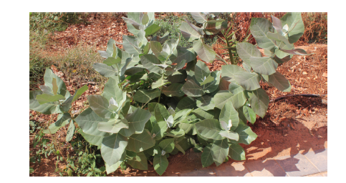

Figure 1. An image of Calotropis procera grown in the UAE University Campus.

Manuscript content flow-
Title
Author name and affiliation
Abstract
Keywords
Abbreviations if any
  - Introduction
  - Materials and Methods
  - Results and Discussions
  - Conclusion
  - Acknowledgements
  - Funding/Conflicts of Interest –if any
  - Author contribution in this Research paper
  - References

